Sprint 3 Plan
Receipt Manager
The Receipt Managers
November 6th , 2025
Revision #1
November 20, 2025

Sprint 3
Goal: Extract text and structured information from receipt images (OCR).
Total: ~21 story points
- {User Story 2.2} As a customer, I want to see all the receipts I have uploaded so I can verify my past physical receipts [12 points].
- FINISHED in SPRINT 2:
  - Allow users to create custom folders to organize receipts [4 points]
    - Create a + folder button
    - Alter firebase schema to allow for the creation of folders
    - Create a form that appears when the + folder button is pressed that allows for user customization (folder name, etc.)
  - Allow users to delete folders [2 points]
  - Link image storage to cloud firestore to retrieve image urls [3 points]
- Cache image urls to display receipt photos in a folder [2 points]
- Retrieve all the relevant receipt data from cloud firestore when a user clicks on a specific receipt (mostly placeholders for now since we haven’t extracted any data yet) [1 point]
- {1} As a customer, I want the app to scan my receipt image and extract key information like store name, total, and date so I can easily track my information [11 points]
- Define a data model for OCR-like fields and types (of data). [1]
  - Should have a sheet-like table look, with overarching headers like stores and dates being top-level, with smaller information like items lower than the store. EX:
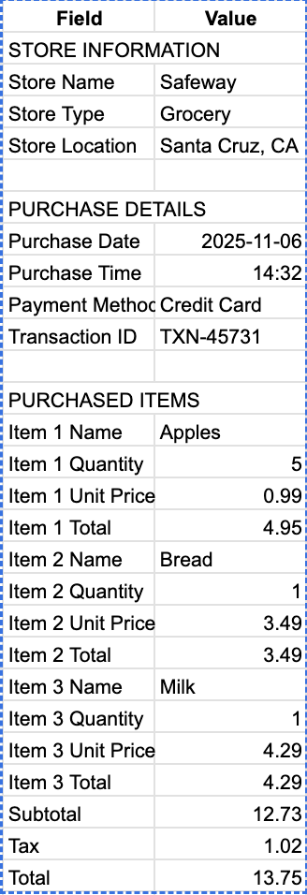
- Integrate on-device text recognition (VisionKit or VNRecognizrTextRequest)[3]
- Build parsing rules like pulling store name, date, subtotal, item names, and price[3]
- Implement a button for rescanning if extrapolation didn’t quite work as intended[1]
- Upload photo from library instead of capturing
- Upload stored information to the Firebase database attached to the receipt and user [3]
  - Most likely will be stored as json data and will need to be translated to fit the database versus the UI view
- {2} As a customer, I want to edit the extracted receipt details so I can correct any scanning errors. [10 points]
- Build an “Edit Receipt” Screen that is prefilled from extracted text before uploading online [3 Points]
- Be able to edit receipt data that is already uploaded online, and see changes reflected in the database [3 Points]
- Track metadata (last edit) and log the information tied to the user’s profile [2 Points]
- {3} As a customer, I want to be able to take multiple photos for a single receipt, so I can scan longer receipts. [5 points]
- Button for multiple photos, or default multiple photos and just choose when to scan image. [2 points]
- Expand library upload to choose multiple photos from the library [2 points]
  - Order the photos to include top and then bottom photo
- Data from each receipt congregated into one table [1 point]

Team Roles
Nate Bagchee: Product Owner {PO}
Merrick Fort: Developer
Bronsen Lasala: Scrum Master
Michael Tong: Developer

Initial Task Assignment
Nate Bagchee: 1.2
Merrick Fort:2.1
Bronsen Lasala: Old 2.2, 1.4
Michael Tong: Old 2.3, 3.1

Scrum Board / Burn Up Chart

